1. Format all cells -> Autofit column width
2. No duplicate Id values found
3. Set revenue to USD Currency
4. Remove unnecessary characters like ‘-’ from NAME

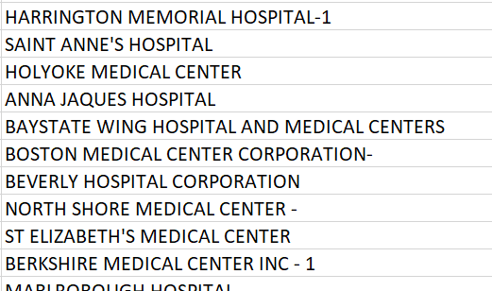 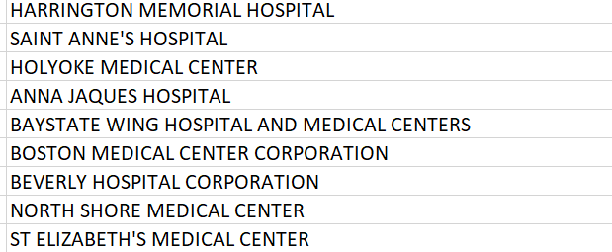

1. Inconsistent capitalization in NAME, along with some values being suffixed by ‘the’
2. TRIM() to remove excess spaces

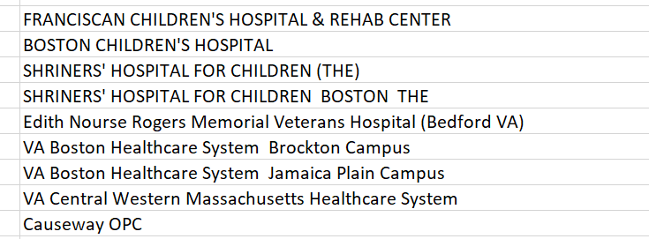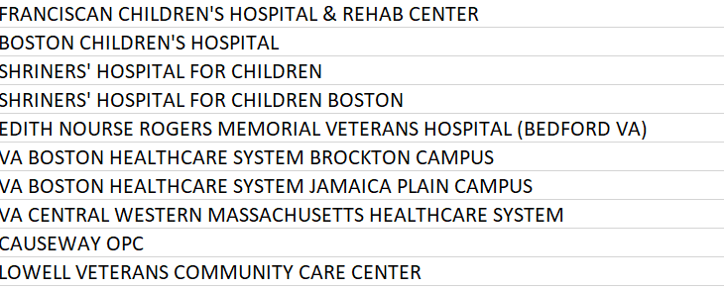

1. PHONE – remove repeated values separated by or

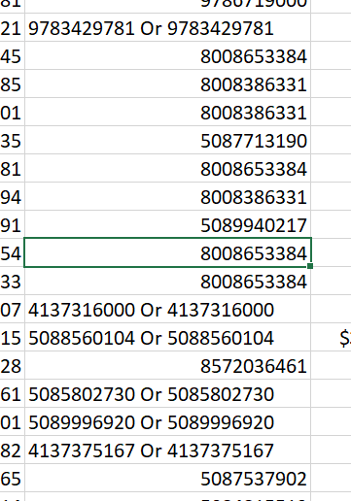 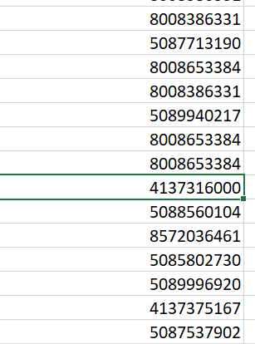

1. Some PHONE values are not of length 10, rendering them invalid

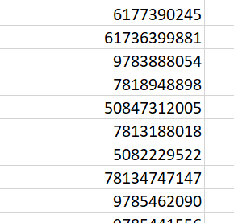 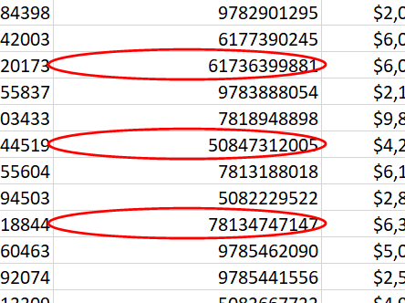

Use data validation to set text length to 10.

Create PHONE_VERIFIED column with formula =IF(AND(ISNUMBER(I2),LEN(I2)=10),I2,"NA")

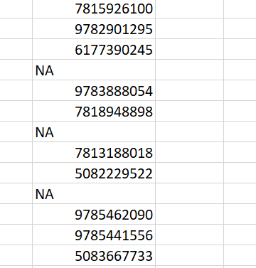

1. Capitalization inconsistencies and zip code format inconsistencies

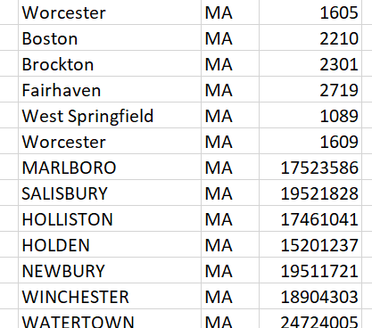

Converting all zip codes to 5 digit format –

=TEXT(LEFT(F2,5),"00000")

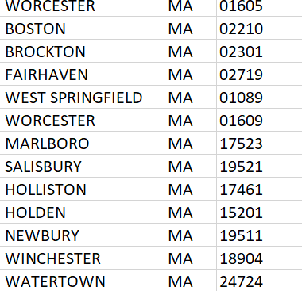

1. Set LAT & LONG as numbers with 6 decimal numbers for consistency

